Accessible and Inclusive Event Planning Checklist
This document has been designed as a tool to help event organizers plan for accessibility and inclusion. The checklist should be reviewed at the beginning of the planning stage. Mohawk College would like to acknowledge the University of Windsor and McMaster University whose accessible events resources offered guidance for the development of this checklist.

Picking a date
The days of significance calendar has been consulted to ensure the proposed date of the meeting/event will not conflict with observance days that could impact participation.
Yes No N/A
Comments:

Accessibility budget
Ensure that funds are available early in the planning process in the event of a request for ASL/sign language interpretation, computerized note taking/real-time captioning, to have materials prepared in braille, dietary needs or any other accessibility features.
Yes No N/A
Comments:

Advertising
Give sufficient notice for your upcoming event; this allows people to arrange for transportation, assistants or other supports they may require.
Yes No N/A
Comments:
On advertisements, include accessibility symbols and the duration of the event. Accessibility symbol examples:
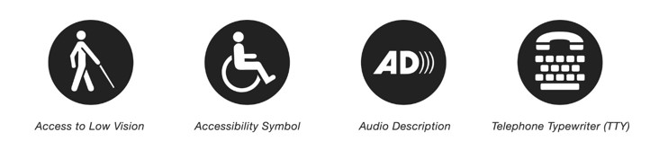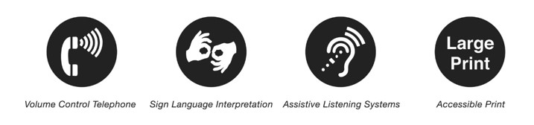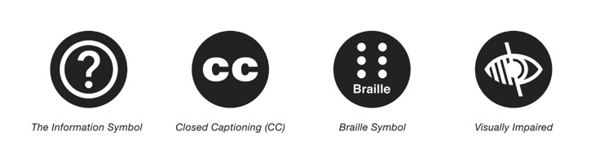
Yes No N/A
Comments:

Registration form
Provide space on your registration form or on the event notice for people to identify their accommodations (physical, alternate formats, etc.) or other specific needs.
A suggested accessibility statement:
“We are committed to providing equitable access to this event for all participants. If you require accommodations, alternative formats, dietary considerations or other specific needs, please contact (name of person) at (number) or via email (email address here) with your request by (deadline).”
Yes No N/A
Comments:
Include your contact information so that potential attendees can contact you with their specific, confidential requests.
Yes No N/A
Comments:
Follow up in a timely manner with people who request accommodations to inform them of availability or any specific instructions/directions.
Yes No N/A
Comments:
If food is being served, give participants a chance to request dietary preferences.
Yes No N/A
Comments:

Meeting/event location
Visit the proposed meeting/event location to determine the accessibility of the room and pathway to reach the room. Ensure that all meeting areas have ramps or elevators and are otherwise accessible so that people with a disability can use all areas at your event independently or with assistance from a volunteer or a support person (i.e., registration desk, auditorium, breakaway rooms, stage, accessible washrooms within a reasonable distance).
Yes No N/A
Comments:
A couple of days before the meeting/event and on the day of the meeting/event, check the elevator and door opening devices to ensure that they are operating properly. Check for any service disruption notices before and on the day of the meeting.
Yes No N/A
Comments:
Elevators should have low buttons for wheelchair users, braille/raised number markings or audible floor announcements for people with low vision, and visual floor indicators for people who are Deaf, deafened or hard of hearing.
Yes No N/A
Comments:
Meeting area is in a quiet location without background noise and/or poor acoustics.
Yes No N/A
Comments:
Determine the approximate distance to nearest accessible parking from the meeting/event location.
Yes No N/A
Comments:
Ensure transportation options for getting to the venue are realistic for people with disabilities. Is a designated drop-off/pick-up location needed?
Yes No N/A
Comments:
Make sure that the accessibility entrance is the main entrance if possible.
Yes No N/A
Comments:
Alternatively, post clear signs at multiple locations showing alternative, safe and accessible entrances. Ensure the signage is in large print with strong colour contrast. Refer to the library’s Accessible Resources: Documents webpage for more information.
Yes No N/A
Comments:
If a phone is available to participants, ensure that it is hearing aid compatible and/or has an amplifier. Also, a teletypewriter (TTY) should be available to participants who are Deaf, deafened or hard of hearing.
Yes No N/A
Comments:
Ensure that you have a private space/room that is designated for breastfeeding and/or prayer.
Yes No N/A
Comments:
Consider the proximity of your meeting/event to breastfeeding and/or prayer space.
Yes No N/A
Comments:

Meeting/event room setup
Aisles between chairs should be 1.5 m or wider to allow for easy movement for wheelchair and scooter users and allow for wheelchair turning radius.
Yes No N/A
Comments:
Tables for individuals using wheelchairs should be no more than 86 cm tall and no less than 72 cm above the floor, with at least 68 cm of knee space between the floor and the underside of the table. Depending on their use think about whether it is appropriate to use tablecloths which could become entangled.
Yes No N/A
Comments:
Allow for plenty of space around tables. To accommodate movement around the table the areas should include a clear space of 1.50 m around all sides of the table.
Yes No N/A
Comments:
Good lighting (bright, without glare and allows for adjustment); no less than 200 lux.
Yes No N/A
Comments:
Stage is easily visible, with a ramp.
Yes No N/A
Comments:
Leave space in the front of the room, near the primary speaking area, for sign language interpreters. Reserve seating near the interpreters for participants who are Deaf, deafened or hard of hearing and consider line of sight.
Yes No N/A
Comments:
Ensure spaces are left at various locations (front, middle and back) in the setup to allow dispersed seating for participants who use mobility devices.
Yes No N/A
Comments:
Cover all electrical cables or cords that cross over aisles or pathways.
Yes No N/A
Comments:
Reduce or eliminate background noise during proceedings.
Yes No N/A
Comments:
Post clear signs showing locations of accessible washrooms, elevators and phones.
Yes No N/A
Comments:

Meeting/event activities
Include specific information in the event description or message saying for example, “This event includes Kahoot or PowerPoint” so that attendees can determine if any accessibility needs will be required.
Yes No N/A
Comments:
A choice of activities that are accessible to all fitness levels, including persons with physical disabilities and different athletic and activity levels (e.g., if there is an exercise such as raising hands).
Yes No N/A
Comments:
Ensure activities are planned with equal attention to the needs of all, with meaningful inclusion of underrepresented groups at all levels of the college community.
Yes No N/A
Comments:

Volunteer training
Ensure that volunteers are easily identifiable. Use name tags and/or other identifiers.
Yes No N/A
Comments:
Train volunteers about how to respectfully assist people with disabilities and to respond to any accessibility issues that may arise.
Yes No N/A
Comments:
Ensure that organizers, presenters and volunteers are aware of the emergency evacuation procedures and refuge areas.
Yes No N/A
Comments:
Know the location of public telephones that are accessible (i.e., with volume control, with a TTY1, and for wheelchair users the coin slot should be 1.22 m above floor level).
Yes No N/A
Comments:
Depending on the nature of the meeting/event, you may want to offer childminding services if many of your attendees have children and the event is held during non-business hours.
Yes No N/A
Comments:
If food is provided, make sure the total count includes interpreters, note takers, attendants and childminders.
Yes No N/A
Comments:

Support persons and service animals
When a participant brings a service animal, provide directions to where the animal can relieve itself and the location of the nearest water fountain for the water dish.
Yes No N/A
Comments:
Ensure there is seating or space far from service animals for persons with severe allergies.
Yes No N/A
Comments:
Consider waiving any fees associated for a support person an individual may require to accompany them.
Yes No N/A
Comments:

Accessible communication and presentations
If the room is equipped with FM transmitters, arrange for Assistive Listening Devices to be available and in working order, or include this notification of availability in your advertising.
Yes No N/A
Comments:
Book American Sign Language (ASL) interpreters or computerized note takers/real-time captioning as soon as possible and at least one month in advance, if these services have been requested.
Yes No N/A
Comments:
Provide interpreters and note takers with agendas and presentation outlines as far in advance as possible to assist in their effectiveness.
Yes No N/A
Comments:
At the meeting/event, ensure that the interpreters and/or captioners are introduced and explain what they will be doing during the event.
Yes No N/A
Comments:
Remind presenters to end on schedule (people making transit arrangements often have very little flexibility).
Yes No N/A
Comments:
Remind presenters to make their presentations accessible (i.e., colour contrast, size, font type, etc.).
Yes No N/A
Comments:
Produce materials including presentation slides and transcripts, etc. in large print (16-point type or larger) in case of a request for such a format, and have available electronically in accessible format.
Yes No N/A
Comments:
Ask attendees to notify the event planner in advance if they require alternative formats or reasonable accommodations. A reasonable accommodation is an adjustment to the environment of an event that allows full participation for people with disabilities, including but is not limited to: providing wheelchair access, allowing service animals, providing sign language interpreters, offering accessible seating and providing equal access to the event. Place this information on your registration.
Yes No N/A
Comments:
For presenters, podium heights and audio-visual controls need to be adjustable to meet the needs of different speakers. Consider the best microphone type to accommodate presenters. Ask presenters about any accommodations they require.
Yes No N/A
Comments:
During the session, presenters should verbally describe contents of videos or any written materials, including overheads or chalkboard notes for those audience members with vision loss. Any digital hand-outs including electronic slides should be accessible.
Yes No N/A
Comments:
Ask presenters to use captioned videos only.
Yes No N/A
Comments:
Organizers or presenters should check with the audience about the need for breaks.
Yes No N/A
Comments:

Evaluating the meeting/event
Include a section about feedback on accessibility and inclusion of the meeting/event. This will provide valuable information for use in future event planning.
Yes No N/A
Comments:

